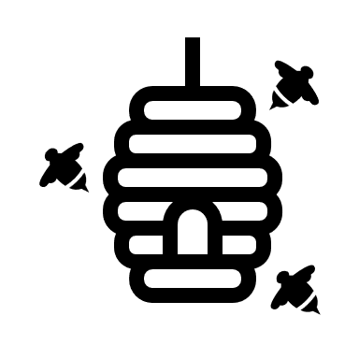

Arduino Code

Data Routing

COM9 Serial Port Connection

DHT 11 Sensor

**ARDUINO(IoT) MODULE**

Live Temperature and Humidity

Beehive Status

Model Architecture and Compilation

H5 File

JSON Module

Data Splitting and Augmentation

Data Cleaning

Data Collection

**DL MODULE**

**BEE-HIVE STATUS/LIVE-MONITORING**

**FLASK**

Image Upload

GET/POST Request

**BEE PHENOTYPE**

Pollen Type

Unhealthy – Varroa Destructor, Nosema etc.

Bee Subspecies

Health

Beehive Status/ Live-Monitoring

Image Upload

Bee Phenotype

**WEB INTERFACE**

User